Kraig Massee

Lab 2 Design

**Step 1.**

**Purpose:** Show a form labeled “Picture Box” with pictures of the numbers 1-5. Numbers can be hovered over or clicked to show a text version of the number. The user can clear the labels and pictures.

**Output:** Tooltip display: “One”, “Two”, “Three”, “Four”, “Five”

On image click, label display below image: “One”, “Two”, “Three”, “Four”, “Five”

On Clear button click: remove images and images labels

On eXit click: Message box displaying “The program will be terminated”

**Input:** Hover over picture box

Mouse click on each picture box

Mouse click on Clear

Mouse click on eXit

Mouse click on “OK” after eXit click

**Process:**

A form will be shown with a label at the top called “Picture Box”. Five images of the Numbers 1-5 will be below this. The program user will be able to hover their mouse over the Images and have a tooltip display which number they hover over. The user can click on the pictures and have a label show below what number was clicked on. A clear button will clear the labels for the pictures and the pictures themselves. Once clicked an exit button will display a message box that the program will be terminated and once the “OK” is clicked the program will exit.

**Step 2.**

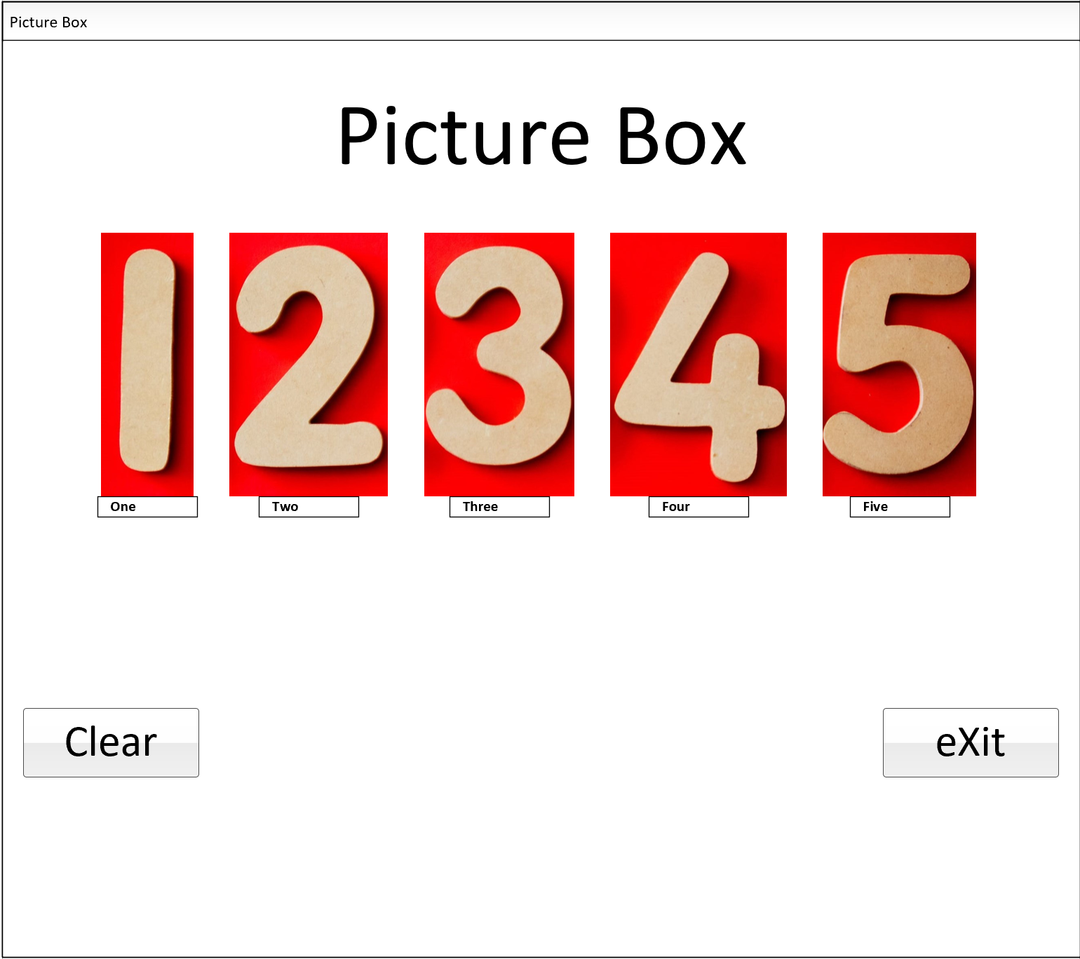

**Step 3.**

|  |  |  |
| --- | --- | --- |
| **Name** | **Description** | **Text** |
| pictureBoxForm | A form that serves as a window to hold the other controls | "Picture Box" |
| mainPictureBoxLabel | Main heading for the form | "Picture Box" |
| onePictureBoxLabel | Label for picture onePictureBox | "One" |
| twoPictureBoxLabel | Label for picture twoPictureBox | "Two" |
| threePictureBoxLabel | Label for picture threePictureBox | "Three" |
| fourPictureBoxLabel | Label for picture fourPictureBox | "Four" |
| fivePictureBoxLabel | Label for picture fivePictureBox | "Five" |
| onePictureBox | Picture box for the “One” image | "" |
| twoPictureBox | Picture box for the “Two” image | "" |
| threePictureBox | Picture box for the “Three” image | "" |
| fourPictureBox | Picture box for the “Four” image | "" |
| fivePictureBox | Picture box for the “Five” image | "" |
| clearButton | On click button that removes picture box labels and picture boxes from form | "Clear" |
| button2 | On click displays message box “The program will be terminated” with a button on the window that says “OK” to exit the program | "eXit" |
| controlToolTip | Controls the tooltip function of the controls | "" |

**Step 4.**

|  |  |
| --- | --- |
| **Method** | **Description** |
| Button2_Click | When the eXit button is clicked the program shows a message boxing stating the program will be terminated. The user can click “OK” and the program will close |
| clearButton_Click | When the Clear button is clicked the picture box and labels associated with the picture boxes are set to null. Removing them from visibility in the form |
| onePictureBox_Click | This sets the onePictureBoxLabel to visible after clicking the onePictureBox |
| twoPictureBox_Click | This sets the twoPictureBoxLabel to visible after clicking the twoPictureBox |
| threePictureBox_Click | This sets the threePictureBoxLabel to visible after clicking the threePictureBox |
| fourPictureBox_Click | This sets the fourPictureBoxLabel to visible after clicking the fourPictureBox |
| fivePictureBox_Click | This sets the fivePictureBoxLabel to visible after clicking the fivePictureBox |